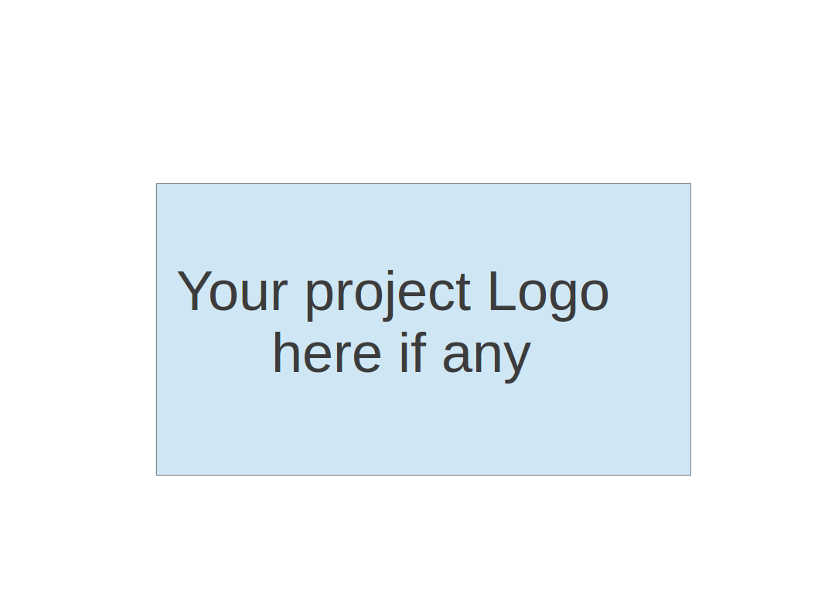
CS673 Software Engineering
Team 3 - Movie Data Visualization Platform
Userstories

[TEAM3-26] User Story 3_6 - Refresh movie data in real-time from external sources Created: 10/Oct/24 Updated: 12/Oct/24
Status: | Icebox
Project: | CS673 Team 3
Components: | None
Affects versions: | None
Fix versions: | None

Type: | Feature | Priority: | Medium
Reporter: | Hengyi Song | Assignee: | Hengyi Song
Resolution: | Unresolved | Votes: | 0
Labels: | None
Σ Remaining Estimate: | Not Specified | Remaining Estimate: | Not Specified
Σ Time Spent: | Not Specified | Time Spent: | Not Specified
Σ Original Estimate: | Not Specified | Original estimate: | Not Specified

Sub-tasks: | Key Summary Type Status Assignee  TEAM3-32 External Data Source Integration for ... Subtask To Do Xuansheng Xia  TEAM3-33 Real-Time Data Fetching and Synchroni... Subtask To Do Xuansheng Xia  TEAM3-34 Automated Visualizations Update Subtask To Do Xuansheng Xia  TEAM3-35 Testing and Validation of Real-Time D... Subtask To Do Xuansheng Xia
Rank: | 0|i0004v:
Story point estimate: | 5

Description

As a system administrator, I want the platform to refresh movie data in real-time from external sources,
So that the visualizations always reflect the latest information without manual updates.

Acceptance Test 1:
Given: The platform is connected to external movie data sources,
When: New data becomes available,
Then: The platform should automatically update the movie information in real-time.

Acceptance Test 2:
Given: The platform is displaying movie data visualizations,
When: The data is refreshed in real-time,
Then: The visualizations should update accordingly to reflect the latest movie information.

[TEAM3-25] User Story 3_5 - Create an account and save my dashboard preferences Created: 10/Oct/24 Updated: 12/Oct/24
Status: | Icebox
Project: | CS673 Team 3
Components: | None
Affects versions: | None
Fix versions: | None

Type: | Feature | Priority: | Medium
Reporter: | Hengyi Song | Assignee: | Hengyi Song
Resolution: | Unresolved | Votes: | 0
Labels: | None
Σ Remaining Estimate: | Not Specified | Remaining Estimate: | Not Specified
Σ Time Spent: | Not Specified | Time Spent: | Not Specified
Σ Original Estimate: | Not Specified | Original estimate: | Not Specified

Sub-tasks: | Key Summary Type Status Assignee  TEAM3-28 User Registration and Account Creation Subtask To Do Xuansheng Xia  TEAM3-29 Dashboard Customization and Preferenc... Subtask To Do Xuansheng Xia  TEAM3-30 User Login and Preference Retrieval Subtask To Do Xuansheng Xia  TEAM3-31 Testing and Validation of Account and... Subtask To Do Xuansheng Xia
Rank: | 0|i0004n:
Story point estimate: | 5

Description

As a frequent user of the platform, I want to create an account and save my dashboard preferences, so that I can return to the platform with my customized settings intact.

Acceptance Test 1:
Given: A dataset of movie reviews,
When: The user requests a word cloud,
Then: The system should generate a word cloud that highlights the most frequently mentioned terms.

Acceptance Test 2:
Given: A dataset of movie reviews,
When: The user requests sentiment analysis,
Then: The system should categorize the reviews into positive, neutral, and negative sentiments.

[TEAM3-24] user story 3-8 Top Movies by Genre Created: 10/Oct/24 Updated: 16/Oct/24
Status: | Icebox
Project: | CS673 Team 3
Components: | None
Affects versions: | None
Fix versions: | None

Type: | Feature | Priority: | Medium
Reporter: | Ziliang Ren | Assignee: | Ziliang Ren
Resolution: | Unresolved | Votes: | 0
Labels: | None
Remaining Estimate: | Not Specified
Time Spent: | Not Specified
Original estimate: | Not Specified

Rank: | 0|i00051:

Description

As a user, I want to see a list of top-rated movies for each genre, so that I can explore the best movies in categories that interest me.
Acceptance Test 1:
Given: A dataset of movies with ratings and genres,
When: The user selects a specific genre,
Then: The system should display a ranked list of the top-rated movies in that genre.
Acceptance Test 2:
Given: A dataset of movies with ratings,
When: The user specifies the number of movies they want to see (e.g., top 10),
Then: The system should adjust the list to display the top-rated movies up to the specified number.

[TEAM3-23] user story 3-7 - Movie Ratings Visualization Created: 10/Oct/24 Updated: 16/Oct/24
Status: | Icebox
Project: | CS673 Team 3
Components: | None
Affects versions: | None
Fix versions: | None

Type: | Feature | Priority: | Medium
Reporter: | Ziliang Ren | Assignee: | Ziliang Ren
Resolution: | Unresolved | Votes: | 0
Labels: | None
Remaining Estimate: | Not Specified
Time Spent: | Not Specified
Original estimate: | Not Specified

Rank: | 0|i0004z:

Description

As a user, I want to visualize the distribution of movie ratings, so that I can understand the overall rating trends for different movies.
Acceptance Test 1:
Given: A dataset of movie ratings,
When: The user requests a ratings distribution visualization,
Then: The system should generate a chart that shows the frequency of each rating across the dataset.
Acceptance Test 2:
Given: A dataset with both high and low ratings,
When: The user filters the data by a specific range (e.g., 4-5 stars),
Then: The system should update the chart to only show the ratings within the specified range.

[TEAM3-6] User Story 3_4 - Apply Custom Filters to Visualized Data Created: 10/Oct/24 Updated: 10/Oct/24
Status: | Icebox
Project: | CS673 Team 3
Components: | None
Affects versions: | None
Fix versions: | None

Type: | Feature | Priority: | Medium
Reporter: | Xuansheng Xia | Assignee: | Xuansheng Xia
Resolution: | Unresolved | Votes: | 0
Labels: | None
Σ Remaining Estimate: | Not Specified | Remaining Estimate: | Not Specified
Σ Time Spent: | Not Specified | Time Spent: | Not Specified
Σ Original Estimate: | Not Specified | Original estimate: | Not Specified

Sub-tasks: | Key Summary Type Status Assignee  TEAM3-11 Implement filter by rating Subtask To Do Xuansheng Xia  TEAM3-12 Implement filter by genre Subtask To Do Xuansheng Xia  TEAM3-13 Implement filter by language Subtask To Do Xuansheng Xia  TEAM3-14 Test filter functionalities Subtask To Do Xuansheng Xia
Rank: | 0|i0000e:i
Story point estimate: | 5

Description

As a user, I want to apply custom filters (e.g., rating, genre, language) to the visualized data, so that I can focus on specific movie categories or attributes relevant to my research.
Acceptance Test 1:
Given: A dataset of movie reviews,
When: The user applies a filter by genre,
Then: The system should display only reviews that belong to the selected genre.
Acceptance Test 2:
Given: A dataset of movie reviews,
When: The user applies a filter by rating,
Then: The system should display only reviews with the selected rating.

[TEAM3-5] User Story 3_3 - Generate Word Cloud and Perform Sentiment Analysis Created: 10/Oct/24 Updated: 10/Oct/24
Status: | Icebox
Project: | CS673 Team 3
Components: | None
Affects versions: | None
Fix versions: | None

Type: | Feature | Priority: | Medium
Reporter: | Xuansheng Xia | Assignee: | Xuansheng Xia
Resolution: | Unresolved | Votes: | 0
Labels: | None
Σ Remaining Estimate: | Not Specified | Remaining Estimate: | Not Specified
Σ Time Spent: | Not Specified | Time Spent: | Not Specified
Σ Original Estimate: | Not Specified | Original estimate: | Not Specified

Sub-tasks: | Key Summary Type Status Assignee  TEAM3-7 Collect movie review dataset Subtask To Do Xuansheng Xia  TEAM3-8 Clean and preprocess the dataset Subtask To Do Xuansheng Xia  TEAM3-9 Perform sentiment analysis Subtask To Do Xuansheng Xia  TEAM3-10 Generate word cloud Subtask To Do Xuansheng Xia
Rank: | 0|i0000e:
Story point estimate: | 8

Description

As a user, I want to generate a word cloud from movie reviews and perform sentiment analysis, so that I can understand the general tone of user feedback and the most frequently mentioned terms in reviews.
Acceptance Test 1:
Given: A dataset of movie reviews,
When: The user requests a word cloud,
Then: The system should generate a word cloud that highlights the most frequently mentioned terms.
Acceptance Test 2:
Given: A dataset of movie reviews,
When: The user requests sentiment analysis,
Then: The system should categorize the reviews into positive, neutral, and negative sentiments.

[TEAM3-2] User Story 3_2 - Analyze Language Diversity in Movies Created: 03/Oct/24 Updated: 11/Oct/24
Status: | Icebox
Project: | CS673 Team 3
Components: | None
Affects versions: | None
Fix versions: | None

Type: | Feature | Priority: | Medium
Reporter: | Xiao Juan Li | Assignee: | Xiao Juan Li
Resolution: | Unresolved | Votes: | 0
Labels: | None
Σ Remaining Estimate: | Not Specified | Remaining Estimate: | Not Specified
Σ Time Spent: | Not Specified | Time Spent: | Not Specified
Σ Original Estimate: | Not Specified | Original estimate: | Not Specified

Sub-tasks: | Key Summary Type Status Assignee  TEAM3-19 Extract and clean movie language data Subtask To Do Xuansheng Xia  TEAM3-20 Analyze language distribution Subtask To Do Xuansheng Xia  TEAM3-21 Create a bar chart visualization Subtask To Do Xuansheng Xia  TEAM3-22 Test the implementation Subtask To Do Xuansheng Xia
Rank: | 0|i0000d:
Story point estimate: | 5

Description

As a user, I want to analyze the diversity of languages used in movies so that I can study trends in language representation in the film industry.
- Acceptance Test 1:

Given the menu “Language Diversity” is available.

When I click on this menu.

Then I should see a bar chart visualizing the number of movies produced in various languages.
- Acceptance Test 2:

Given the bar chart of language diversity is displayed.

When I hover over a specific language bar.

Then I should see the exact number of movies produced in that language as a tooltip or label.

[TEAM3-1] User Story 3_1- Explore Movie Runtimes Created: 03/Oct/24 Updated: 11/Oct/24
Status: | Icebox
Project: | CS673 Team 3
Components: | None
Affects versions: | None
Fix versions: | None

Type: | Feature | Priority: | Medium
Reporter: | Xiao Juan Li | Assignee: | Xiao Juan Li
Resolution: | Unresolved | Votes: | 0
Labels: | None
Σ Remaining Estimate: | Not Specified | Remaining Estimate: | Not Specified
Σ Time Spent: | Not Specified | Time Spent: | Not Specified
Σ Original Estimate: | Not Specified | Original estimate: | Not Specified

Sub-tasks: | Key Summary Type Status Assignee  TEAM3-15 Extract and clean movie runtime data Subtask To Do Xuansheng Xia  TEAM3-16 Analyze runtime distribution Subtask To Do Xuansheng Xia  TEAM3-17 Create a histogram visualization Subtask To Do Xuansheng Xia  TEAM3-18 Test the implementation Subtask To Do Xuansheng Xia
Rank: | 0|i0000b:
Story point estimate: | 5

Description

As a user, I want to explore the distribution of movie runtimes so that I can study trends in movie length across the industry.
- Acceptance Test 1:
Given the menu “Movie Runtimes” is available.
When I click on this menu.
Then I should see a histogram where the x-axis displays specific runtime ranges (e.g., 0-60 minutes, 61-120 minutes) and the y-axis shows the number of movies in each runtime range.
- Acceptance Test 2:
Given the histogram of movie runtimes is displayed.
When I hover over a specific runtime range (e.g., 61-120 minutes).
Then I should see the exact number of movies in that range as a tooltip or label.

Generated at Fri Oct 18 05:00:32 UTC 2024 by Xiao Juan Li using Jira 1001.0.0-SNAPSHOT#100270-rev:582039e53e997ecddb7d2905e1827db609c6b94f.

